**Scenario 1:** **The bank needs to process monthly interest for all savings accounts**

**Question: Write a stored procedure ProcessMonthlyInterest that calculates and updates the balance of all savings accounts by applying an interest rate of 1% to the current balance.**

**Source code**

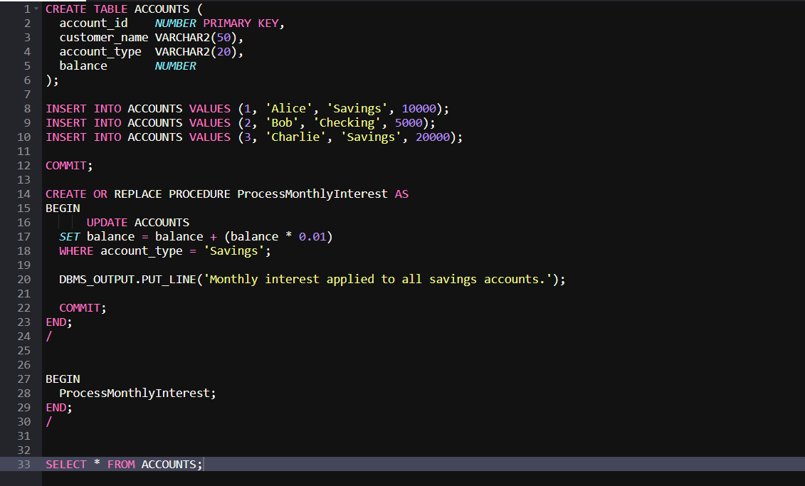

**Output**

